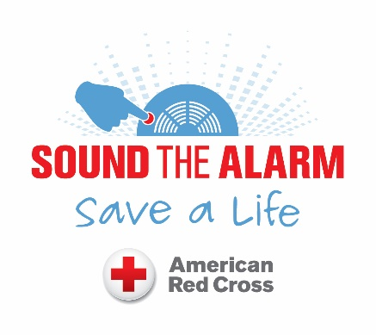

**Free Smoke Alarm Installation**



You may have as little as

**2 minutes**

to escape a burning home

**before it’s too late**

Scan this with your phone to sign up on the go!!

**Every day, 7 people in this country will perish in a home fire.**

**A working smoke alarm can cut your risk of death in a house fire in half.**

**American Red Cross of Hawai’i is installing free smoke alarms in homes and educating on fire prevention and how to escape from home fires.**

**3 easy ways to get your free smoke alarms installed by a Red Cross Volunteer**

1. **Call:**

**808-245-4919**

1. **Online:** <https://redcrosshawaii.wufoo.com/forms/z12y8gbi170d9zc/>
2. **E-mail:** [padraic.gallagher@redcross.org](mailto:padraic.gallagher@redcross.org)